Project Design Phase-II
Technology Stack (Architecture & Stack)

Date | 31 January 2025
Team ID | 6ab4bf896f290be8a6b413e7
Project Name | AI WeatherWise API
Maximum Marks | 4 Marks
Team Leader: Jayavarshini B (TN Skills ID: CAF381BC6958D42A7054C2311E6E5A71); Team Members: Kanagavalli S (TN Skills ID: 43DB4066274811FB5BD479D7B7B9C7D7), Keerthana S (TN Skills ID: 9E0CD16F105D26789DB453C13F846CE1), Manisha R (TN Skills ID: D22BAB6B378290B80E34E0EBF98419E5).
GitHub Repository: https://github.com/Keerthanabca2024/Weatherwise_API.git

Technical Architecture:
The Deliverable shall include the architectural diagram as below and the information as per the table1 & table 2
Example: Order processing during pandemics for offline mode
Reference: https://developer.ibm.com/patterns/ai-powered-backend-system-for-order-processing-during-pandemics/

Table-1 : Components & Technologies:
S.No | Component | Description | Technology
 | User Interface | How user interacts with application e.g.  Web UI, Mobile App, Chatbot etc. | HTML, CSS, JavaScript / Angular Js / React Js etc.
 | Application Logic-1 | Logic for a process in the application | Java / Python
 | Application Logic-2 | Logic for a process in the application | IBM Watson STT service
 | Application Logic-3 | Logic for a process in the application | IBM Watson Assistant
 | Database | Data Type, Configurations etc. | MySQL, NoSQL, etc.
 | Cloud Database | Database Service on Cloud | IBM DB2, IBM Cloudant etc.
 | File Storage | No file-upload feature is implemented in the source code. The package.json includes multer, but no upload route/controller uses it. | Not applicable to current implementation
 | External API-1 | Purpose of External API used in the application | IBM Weather API, etc.
 | External API-2 | Purpose of External API used in the application | Aadhar API, etc.
 | Machine Learning Model | Purpose of Machine Learning Model | Object Recognition Model, etc.
 | Infrastructure (Server / Cloud) | Application Deployment on Local System / Cloud  Local Server Configuration:  Cloud Server Configuration : | Local, Cloud Foundry, Kubernetes, etc.

Table-2: Application Characteristics:
S.No | Characteristics | Description | Technology
 | Open-Source Frameworks | List the open-source frameworks used | Technology of Opensource framework
 | Security Implementations | List all the security / access controls implemented, use of firewalls etc. | e.g. SHA-256, Encryptions, IAM Controls, OWASP etc.
 | Scalable Architecture | Justify the scalability of architecture (3 – tier, Micro-services) | Technology used
 | Availability | Justify the availability of application (e.g. use of load balancers, distributed servers etc.) | Technology used
 | Performance | Design consideration for the performance of the application (number of requests per sec, use of Cache, use of CDN’s) etc. | Technology used

References:
https://c4model.com/
https://developer.ibm.com/patterns/online-order-processing-system-during-pandemic/
https://www.ibm.com/cloud/architecture
https://aws.amazon.com/architecture
https://medium.com/the-internal-startup/how-to-draw-useful-technical-architecture-diagrams-2d20c9fda90d

Technical Architecture – AI WeatherWise API
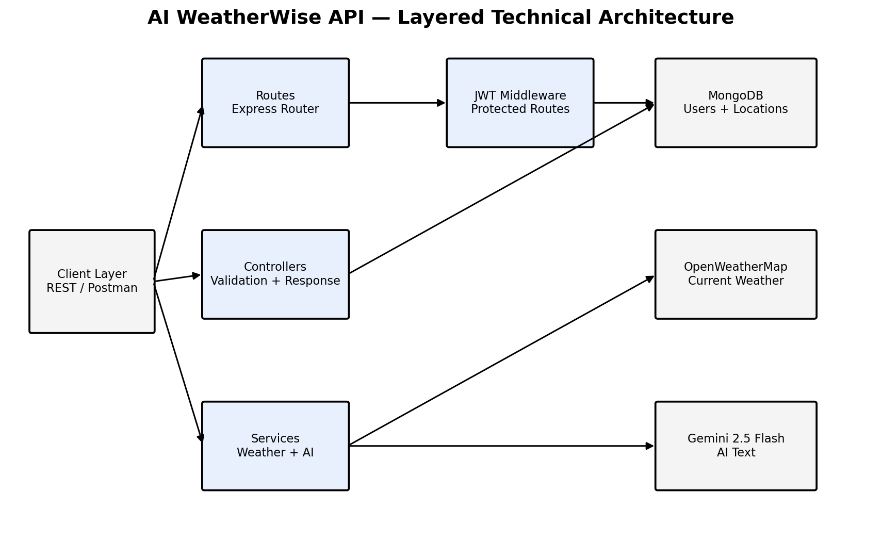
Figure 3: Technical Architecture of the AI WeatherWise API
Table-7: Components & Technologies
Table-8: Application Characteristics
S.No | Component | Description | Technology
1. | User Interface | The project is a backend API without a graphical interface. Clients interact through HTTP requests, tested with a Postman collection. | REST / JSON, Postman
2. | Application Logic-1 | Authentication (register, login, profile), JWT authorisation guard, and favourite-location management. | Node.js, Express.js, jsonwebtoken, bcryptjs
3. | Application Logic-2 | Weather service that queries OpenWeatherMap by city name and falls back to mock data. | Node.js (fetch), OpenWeatherMap API
4. | Application Logic-3 | AI service that builds prompts for summaries and recommendations and falls back to rule-based text. | @google/generative-ai, Google Gemini API
5. | Database | Stores user accounts and favourite locations as documents defined by the User and Location schemas. | MongoDB with Mongoose ODM
6. | Cloud Database | MongoDB Atlas is supported as the hosted database option. | MongoDB Atlas
7. | File Storage | No file-upload feature is implemented in the source code. The package.json includes multer, but no upload route/controller uses it. | Not applicable to current implementation
8. | External API-1 | Retrieves current weather (temperature, humidity, wind speed and condition) in metric units. | OpenWeatherMap API
9. | External API-2 | Generates natural-language weather summaries and recommendations. | Google Gemini API
10. | Machine Learning Model | Generative AI model used through the Gemini API for weather summaries and personalised recommendations. | Gemini 2.5 Flash (gemini-2.5-flash)
11. | Infrastructure (Server / Cloud) | Application deployment on a local system.  Local Server Configuration: Node.js v18 or later and npm; default port 5000 (configurable through PORT); started with npm start or npm run dev.  Cloud Server Configuration: Local Node.js deployment is documented; MongoDB Atlas is supported as the hosted database option. No cloud application-server deployment is included in the supplied code. | Local (Node.js runtime)
S.No | Characteristics | Description | Technology
1. | Open-Source Frameworks | Open-source frameworks and libraries used for the web server, database access, security and configuration. | Express.js, Mongoose, cors, dotenv, jsonwebtoken, bcryptjs, nodemon (development)
2. | Security Implementations | Password hashing with 10 salt rounds; JWT Bearer authentication with 30-day expiry; protected routes; ownership checks on location updates and deletions; password excluded from user queries; input validation; secrets kept in environment variables excluded from version control. | bcryptjs, JWT, .env / .gitignore
3. | Scalable Architecture | Layered MVC structure (routes, controllers, services and models) with stateless token-based authentication and a database that can be hosted on MongoDB Atlas. | Node.js / Express.js, MongoDB
4. | Availability | Fallback to mock weather data and rule-based AI text keeps endpoints responding when external services are unavailable. Load balancing/distributed servers: not implemented in the supplied code; fallback logic is used for service resilience. | Fallback services
5. | Performance | Compound unique index on user, city and country for location queries. Request-rate target: proposed baseline of 60 requests/minute for initial deployment; caching/CDN are not implemented in the supplied code. | MongoDB indexing

